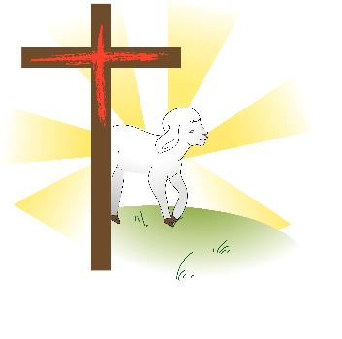**THE BOOK OF HEBREWS**

**7. Jesus: High Priest like Melchizedek**

Introduction

As we have studied the Book of Hebrews we have seen that Jesus is the High Priest over God’s House. There is one phrase that is used again and again in chapters 5 to 7, and it is the phrase, ‘Jesus is High Priest in the order of Melchizedek.’ See Hebrews 5:6, 10, 6:20, 7:17. Obviously this is important. In Hebrews 7 it explains the meaning of this to us, so let’s study that chapter now.

1. Melchizedek the Priest Hebrews 7:1-10

❖ What do we learn about Melchizedek from verses 1 to 3? Also see Genesis 14:18-20.

❖ The name Melchizedek is very significant. What does his name mean and how does it point to Jesus?

See Isaiah 9:6-7, Jeremiah 23:5-6.

❖ There was one incident that showed how Melchizedek was greater than Aaron and the Levitical Priests.

What is it, and how does it prove that he was greater? V4-10

2. Jesus, like Melchizedek Hebrews 7:11-28

Up until the time of Jesus, the priests had all been descendants of the tribe of Levi, and the High Priest had been from the lineage of Aaron. Now there was a new High Priest, who had not come from this heritage, yet he was greater. He was like Melchizedek.

❖ How was Jesus like Melchizedek? V13-17

❖ Why was the old priesthood of Aaron and Levi set aside? V11, 18

❖ What three reasons are given to show that the new priesthood is better? V19-22, 23-25, 26-27.

❖ What does Jesus, our High Priest do for us? V25, 26, 27

❖ Share what encourages you most from these verses and tell us why.

Conclusion

This chapter closes with a summary in verse 28, ‘For the law appoints as high priests men who are weak; but the oath, which came after the law, appointed the Son, who has been made perfect forever.’ The priesthood that began in the time of Aaron is now set aside and we have a new High Priest who is infinitely greater. He is the One God promised to give – the One after the order of Melchizedek and his name is Jesus, the Son of God. Let’s worship him!